AMERICAN YOUTH SOCCER ORGANIZATION 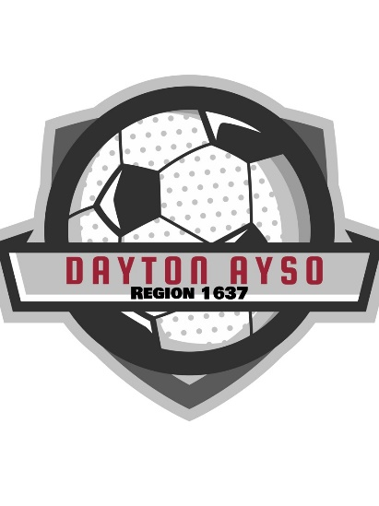

A nonprofit corporation dedicated to youth soccer

**AYSO REGION 1637 – LYON COUNTY**

DAYTON ~ VIRGINIA CITY ~ SILVER SPRING

STAGECOACH ~ MOUND HOUSE

SPONSORSHIP FORM

AYSO is a tax-exempt, nonprofit corporation under Internal Revenue Code 501(c)3. AYSO offers children an opportunity to grow through sports. With your generous donation, you will be helping your community and your community’s children as well as giving your company added exposure. There are several levels in which your business can choose to sponsor AYSO Region 1637 (please check one):

* Platinum Sponsor – $750.00
  + Social Media acknowledgement
  + Sponsor banner presented at local league games
  + Special Advertisement at team events
  + Profession Thank You Plaque
* Gold Sponsor - $500.00
  + Social Media acknowledgement
  + Sponsor banner presented at local league games
  + Special Advertisement at team events
* Silver Sponsor - $250.00
  + Social Media acknowledgement
  + Sponsor banner presented at local league games
* Bronze Sponsor - $100.00
  + Social Media acknowledgement

Sponsor Name: _____________________________________________________

(Name to be displayed for publicity purposes)

Business Email: _______________________________

Address: ___________________________ City:__________________ State: _____ Zip Code:_________

If you would like to sponsor a specific team or child, please fill in the information below – if you don’t have a specific child or team to sponsor, we will assign a team to your sponsorship.

Team Name: ________________________________________________________

Coach: _____________________________________

Player’s Name: ______________________________________________________

Division (or age) : ______________

I am including a check made out to: ***AYSO Region 1637***

Please return check and this form to:

AYSO Region 1637

Attn: Treasurer Chair

PO Box 1536

Dayton, NV 89403

Admin Use Only: Date Received: _______________

Check #: _____________Amount $ _____________